**Lab 2**

1. Do an nslookup of Starbucks.com and record the “IP Addresses” returned. Record your answer here. IP address is highlighted.

C:\Users\natal>nslookup starbucks.com

Server: dns-cac-lb-02.rr.com

Address: 209.18.47.62

Non-authoritative answer:

Name: starbucks.com

Address: 104.122.53.123

1. Do a whois lookup for starbucks.com by “IP Address” returned in the previous question. Using the domain perform a "IP History" search at viewdns.info. Record your answer here.

**Whois lookup by IP Address:**

**viewdns.info:**

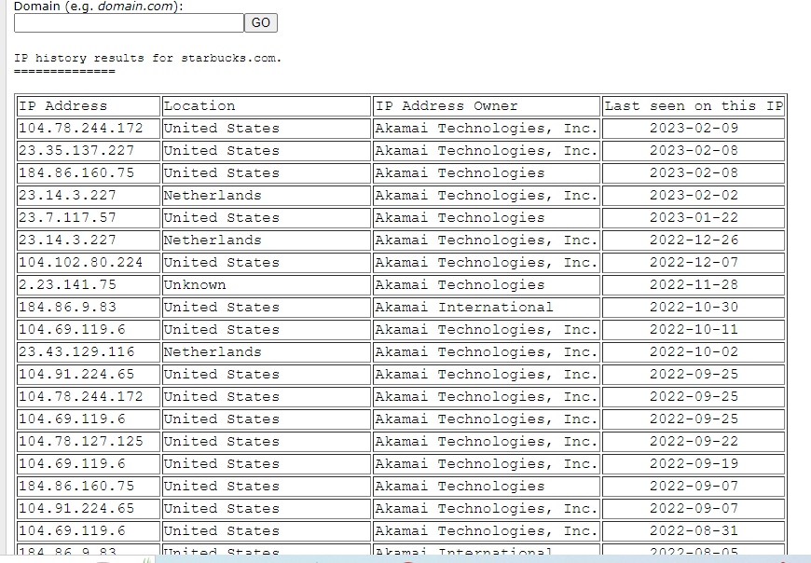

1. Perform the whois lookup for starbucks.com at domaintools.com. Record your answer here.

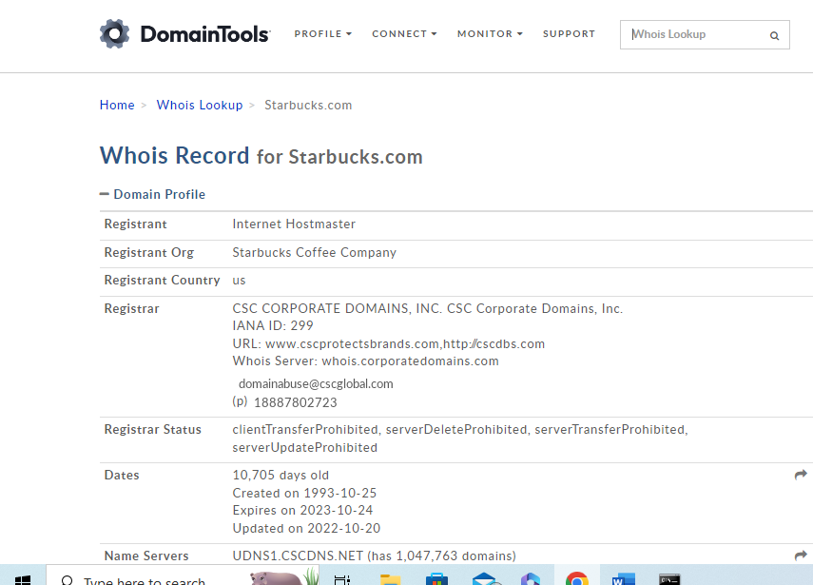

1. Using the whois.net perform the whois lookup for Starbucks.com.

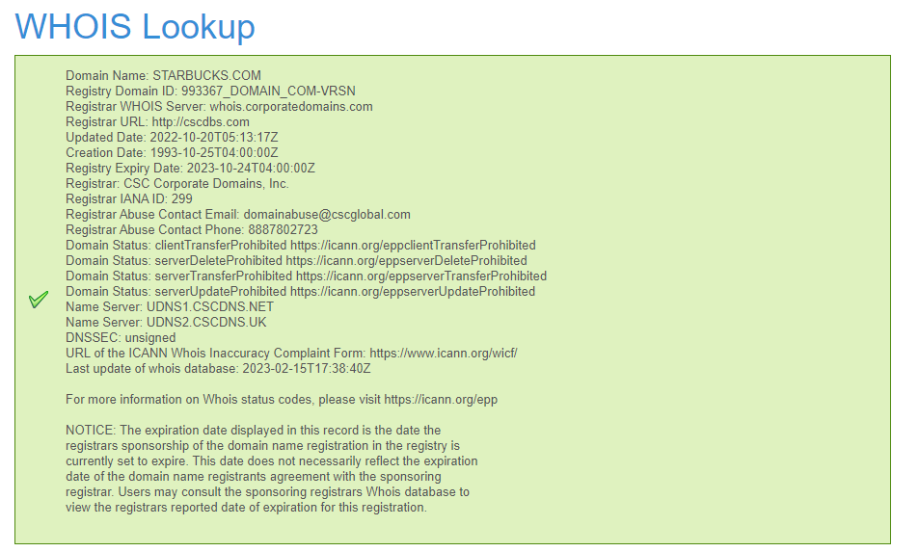

1. Compare the returned results from questions 2 and 3 and record any differences you find, if any. - 10 points

Both results provide information on an IP address and location of the domain name starbucks.com. Question 2 contains a list of IP addresses that differ from the IP address resulted in question 3. Question 2 lists all the IP addresses in their history and from all the different locations. Question 3 provides more information on the domain, including location, contact information, servers, and brief description of IP history.

1. Perform a Google search inurl.Starbucks.com, Record the first 5 links. Record your answer here and identify any unusual or interesting links uncovered.

The top three links show the official website page of Starbucks, while the bottom two show interesting website links to HackerOne. Starbucks seems to offer a program or enlists the help of hackers to improve security efforts and reduce vulnerabilities.

1. Perform a Google search “filetype:pdf pdf site:starbucks.com”. Record your answer here and identify any unusual or interesting links uncovered.

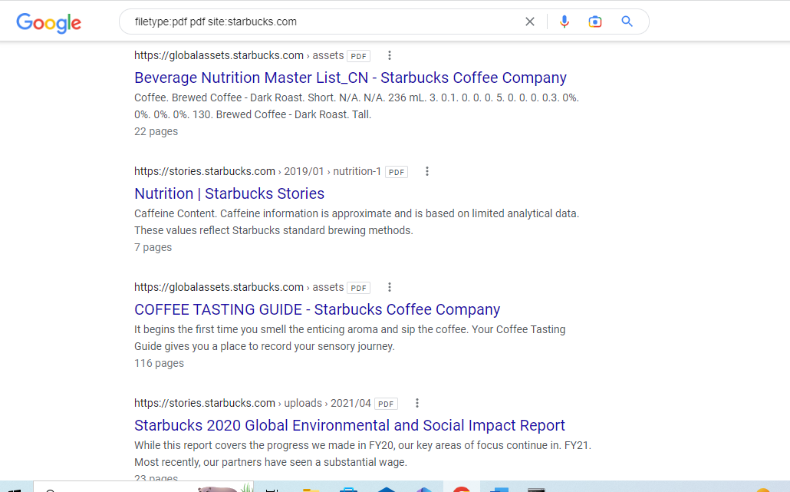

This shows links to pdfs associated with Starbucks information, reports, and nutrition guides.

1. Perform a Google search using one the directives coved in the module. Record your answer here and identify any unusual or interesting links uncovered. - 10 points

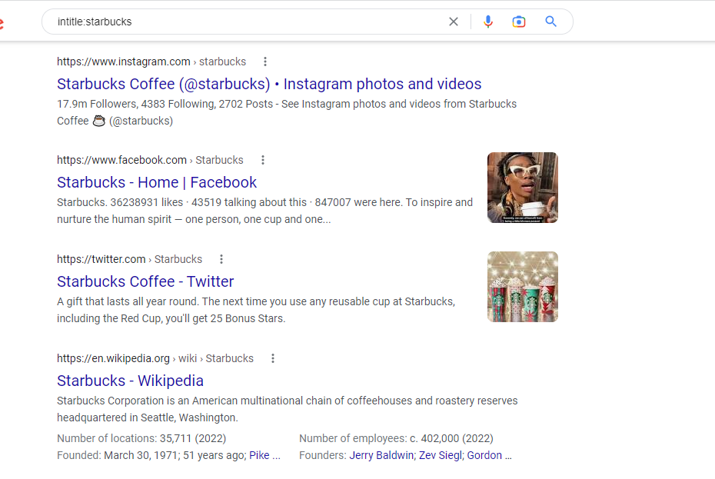

Using the intitle directive. Contains all the links with the term Starbucks in its title, with some from social media sites.

1. Go to sec.gov and lookup Starbucks. Get to the company financial page and find the latest SEC filings. Open the company’s last 10-k filing. Record their corporate phone number and address here.

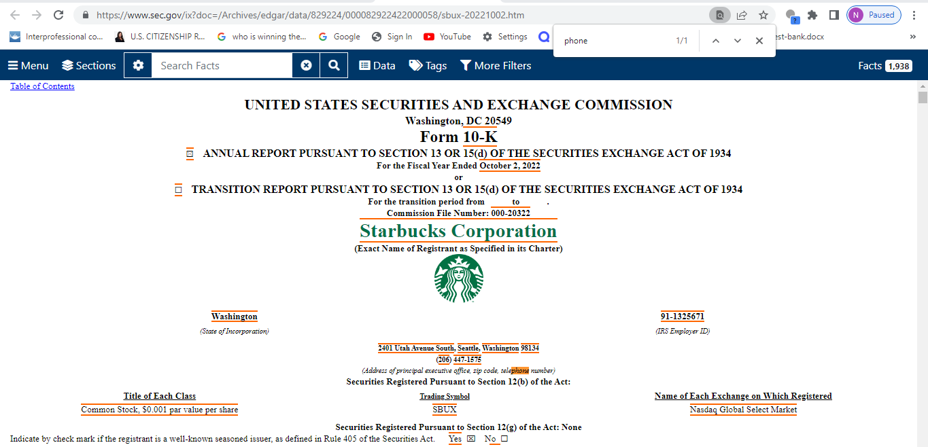

Corporate phone number: (206) 447-1575

Address: 2401 Utah Avenue South, Seattle, Washington 98134

1. 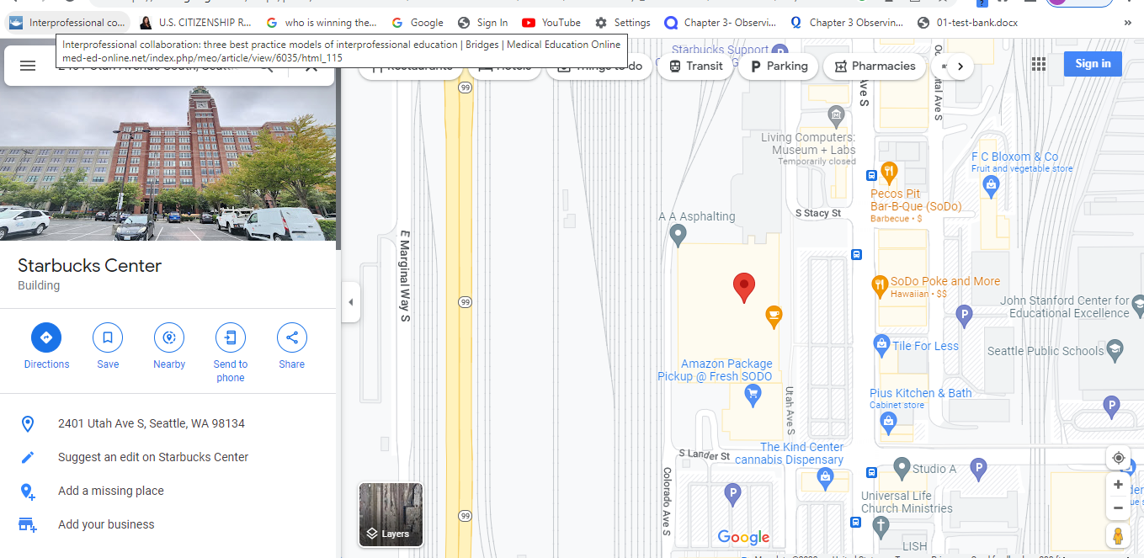Go to Google maps and using the corporate address find and capture a map of the location here.
2. Graphical user interface, application

   Description automatically generated Go to sec.gov and lookup Starbucks. Get to the company 10-k filing find the Executive Officers of the Resident. Record the names listed here. - 10 points

Executive Officers: Howard Schultz, Laxman Narasimhan, Michael Conway, Zabrina Jenkins, and Rachel Ruggeri

1. Using Google, look up one of the people from the executive officers (except Howard Shultz). Record a previous place of employment and the url you got the information from here.

After researching Laxman Narasimhan, I found that a previous place of employment was CEO of the U.K.-based cleaning and health products manufacturer Reckitt Benckiser. This information was found at <https://www.forbes.com/sites/nicholasreimann/2022/09/01/starbucks-new-ceo-heres-what-to-know-about-laxman-narasimhan/?sh=477912821bea>.

1. Using the https://www.xml-sitemaps.com/ generate a sitemap for “www.starbucks.com” In the results, find the link(s) related to “Landload FAQs” and past the URL here.

|  |  |  |
| --- | --- | --- |
| https://www.starbucks.com/business/landlord-faq/ | 2023-02-15T19:32:30+00:00 | 0.80 |
| https://www.starbucks.com/account/signin?ReturnUrl=%2Fbusiness%2Flandlord-faq | 2023-02-15T19:32:30+00:00 | 0.64 |
| https://www.starbucks.com/account/signout?ReturnUrl=%2Fbusiness%2Flandlord-faq | 2023-02-15T19:32:30+00:00 | 0.64 |
| https://www.starbucks.com/business/landlord-faq/eft-direct-deposit/ | 2023-02-15T19:32:30+00:00 | 0.64 |
| https://www.starbucks.com/business/landlord-faq/contacting-starbucks/ | 2023-02-15T19:32:30+00:00 | 0.64 |
| https://www.starbucks.com/business/landlord-faq/account-management/ | 2023-02-15T19:32:30+00:00 | 0.64 |
| https://www.starbucks.com/business/landlord-faq/landlord-billing/ | 2023-02-15T19:32:30+00:00 | 0.64 |
| https://www.starbucks.com/account/signin?ReturnUrl=%2Fbusiness%2Flandlord-faq%2Feft-direct-deposit | 2023-02-15T19:32:30+00:00 | 0.51 |
| https://www.starbucks.com/account/signout?ReturnUrl=%2Fbusiness%2Flandlord-faq%2Feft-direct-deposit | 2023-02-15T19:32:30+00:00 | 0.51 |
| https://www.starbucks.com/account/signin?ReturnUrl=%2Fbusiness%2Flandlord-faq%2Fcontacting-starbucks | 2023-02-15T19:32:30+00:00 | 0.51 |
| https://www.starbucks.com/account/signout?ReturnUrl=%2Fbusiness%2Flandlord-faq%2Fcontacting-starbucks | 2023-02-15T19:32:30+00:00 | 0.51 |
| https://www.starbucks.com/account/signin?ReturnUrl=%2Fbusiness%2Flandlord-faq%2Faccount-management | 2023-02-15T19:32:30+00:00 | 0.51 |
| https://www.starbucks.com/account/signout?ReturnUrl=%2Fbusiness%2Flandlord-faq%2Faccount-management | 2023-02-15T19:32:30+00:00 | 0.51 |
| https://www.starbucks.com/account/signin?ReturnUrl=%2Fbusiness%2Flandlord-faq%2Flandlord-billing | 2023-02-15T19:32:30+00:00 | 0.51 |
| https://www.starbucks.com/account/signout?ReturnUrl=%2Fbusiness%2Flandlord-faq%2Flandlord-billing | 2023-02-15T19:32:30+00:00 | 0.51 |

1. Retrieve the robots.txt file from Starbucks.com and record it here. -10 Points

# Slow an overly aggressive MJ12bot from the UK

User-Agent: MJ12bot

Crawl-Delay: 5

User-agent: *

Disallow:

Sitemap: https://www.starbucks.com/sitemap.txt